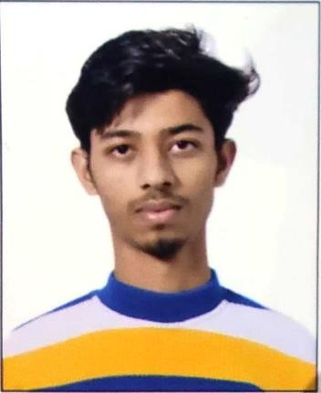

House no.1266 Gali no. 05 near Bijwasan railway station Delhi 110061

8527663278

[manishkk@gmail.com](mailto:manishkk@gmail.com)

**DATE OF BIRTH:**

27.02.2002

**SKILLS**

* **Classroom and behavior**
* **Management**
* **Lesson & Curriculum Planning**
* **Effective Communication**
* **Leadership Skills**
* **Compassion & Empathy**
* **Time management**
* **Decision Making**
* **Problem Solving**
* **Interpersonal Skills**
* **Enthusiasm & Energy**

**LANGUAGES**

**English, Hindi:** First Language

MANISH

Special Educator

# PROFILE

* **Creative and patient teacher with great communication skills and a bold approach to creating effective lesson plans.**
* **While working with children always focus on the interests, strengths, and needs of the child.**
* **Use different approaches to teach the child.**
* **Works with modern technology and useful TLMs.**
* **Believes in teamwork with co-workers, children**, **and parents.**
* **Gives regular feedback and tries, to solve queries of parents regarding their child.**

# EDUCATION

QUALIFIED CTET- March, 2023 RCI LICENSE HOLDER

**D.ED. SPL. ED(ASD)** | 2020-2022 TAMANA SCHOOL OF HOPE , New Delhi

* **Secured 68.16% in the first year.**
* **Secured 74% in the second year.**

**Bachelor of Arts**| 2019-2022 SOL , New Delhi

* **Secured 6.27 CGPA in the first year.**
* **Secured 7 CGPA in the second year.**
* **Secured 6.68 CGPA in the third year.**
* **GRAND CGPA = 6.652**

**Higher Secondary** | 2018-2019 Govt Boys Senior Secondary School Bijwasan , New Delhi

* **Art’s Attaind 80% in CBSE board.**



# EXPERIENCE

# Beautiful mind therapy centre – 3 Months

December 2022 - Current

**SPECIAL EDUCATOR, TAMANA SCHOOL OF HOPE** | VASANT VIHAR

* Created IEP for 4 cases (2- AUTISM SPECTRUM DISORDER, 1- INTELLECTUAL DISABILITY, 1- MULTIPLE DISABILITY)- WITH SUPPORTED TLM.
* CREATED 30 GROUP LESSON PLANS.
* CREATED MORE THAN 10 SOCIAL STORIES.
* WORKED ON COMMUNICATION USING PICTURE EXCHANGE COMMUNICATION SYSTEM.
* WORKED ON ORAL / GUSTATORY SENSORY ISSUE OF A CHILD & MADE THE CHILD UNDERSTAND THE CONCEP

OF EDIBLE AND INEDIBLE.

WORKED ON BEHAVIOR MANAGEMENT - SITTING TOLERANCE

September 2021 - February 2022

**ICT TEACHER, TAMANA SCHOOL OF HOPE** | New Delhi

* Volunteered as a computer teacher.
* worked with 2 students diagnosed with autism spectrum disorder.

October 2019 - March 2020

**INVIGILATOR NIOS & CBSE** | New Delhi

# CERTIFICATIONS

* + **DITC course from agilo skill india from pala March 2019 September 2019**
  + **Prayas Save Environment held on June 2019**
  + **Quiz Competiton ( ITC ) Agilo Skill India (Palam)**
  + **Certificte Course In Computer Application ( June 2017 Octuber 2017)**